Image Analysis in Fiji ImageJ for CD68/Iba1 Staining
Values to Use
- CD68 (red)
  - Threshold: 46, 255
- Iba1 (green)
  - Threshold: 22, 255
Settings
Before starting the image analysis make sure you have the correct measurements selected in the settings (area, integrated density, % area). You need to have % area for this analysis.
- Go to “Analyze” tab > “Set Measurements” and make sure the measurements are selected as seen in the image.
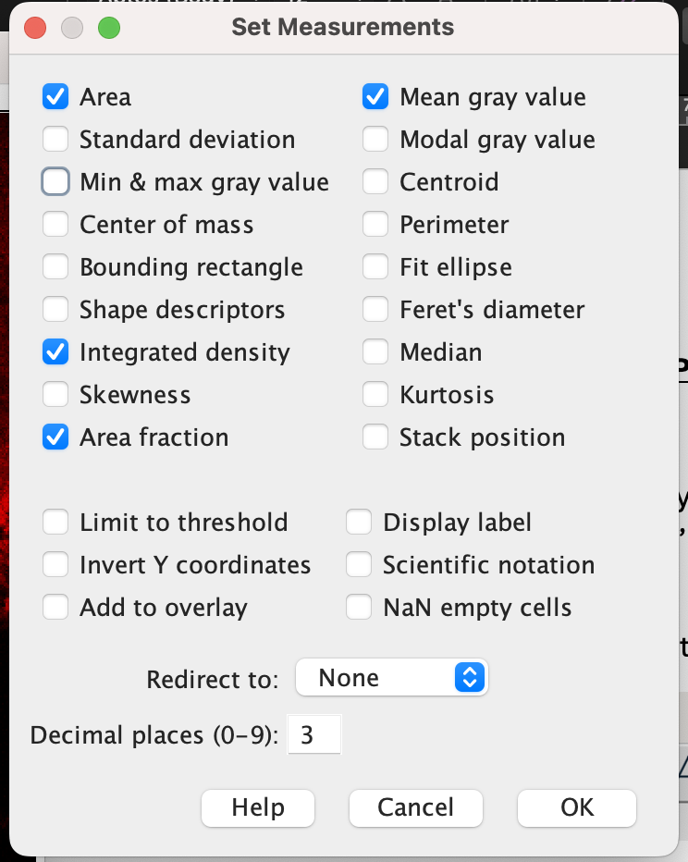
- Go to “Edit” tab > “Options” > “Colors” > Make sure “Foreground” is set to white, and “Background” is set to black. Selection color does not matter.
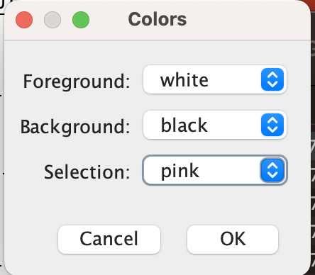
- Go to “Process” tab > “Binary” > “Options” > Make sure options are set as seen below
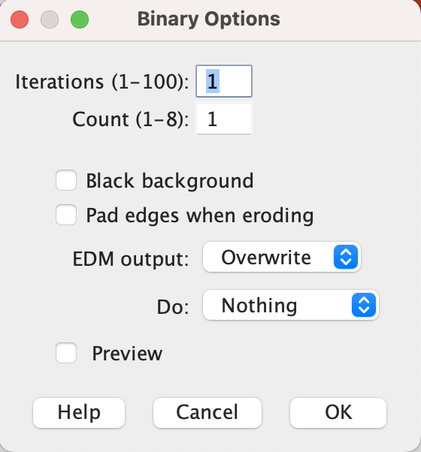

Finding Area/Intensity Data
- Drag and drop the image into Fiji ImageJ
- Scroll to DAPI (blue) channel for hippocampus (HPC) images to make a selection
  - Note: No selection for cortex images (CTX) needed
- Make a selection for HPC images featuring a bright granular line only
  - Hippocampus (HPC)
    - Use the polygon tool to outline around the area you want.
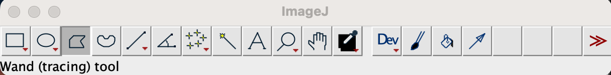
    - Make the selection to exclude the bright granular line(s) on the image (see image below).
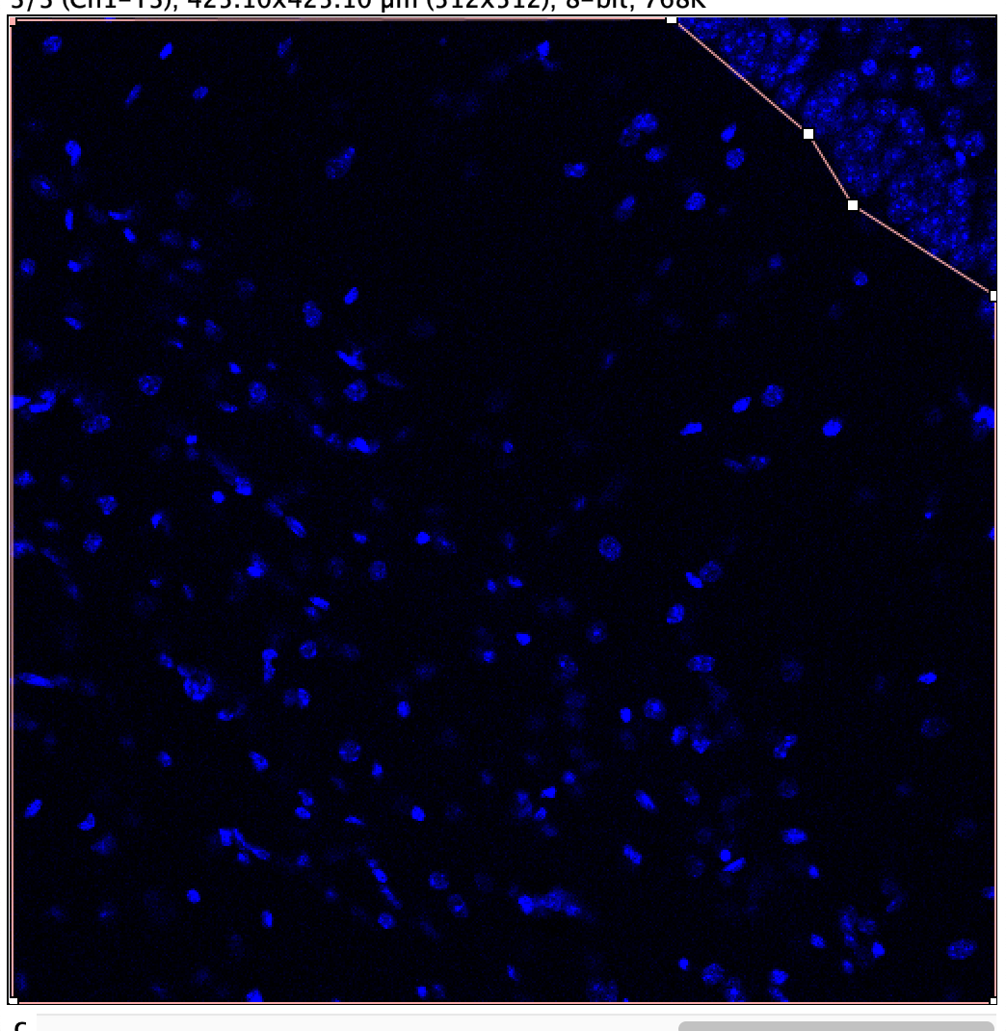
    - Save your selections in a separate folder, you need them again later. Go to “File” tab > “Save As” > “Selection” to save your selection.
- Split images: Go to “Image” tab > “Color” > “Split Channels”
- Close the DAPI (blue) image
- Click on the CD68 (red) image
- Make 8-bit image: Go to “Image” tab > “Type” > “8-bit”
- Adjust threshold: Go to “Image” tab > “Adjust” > “Threshold”
  - Click on “Set” in the popup window and then set the threshold at a consistent value of: Lower: 46, Upper: 255
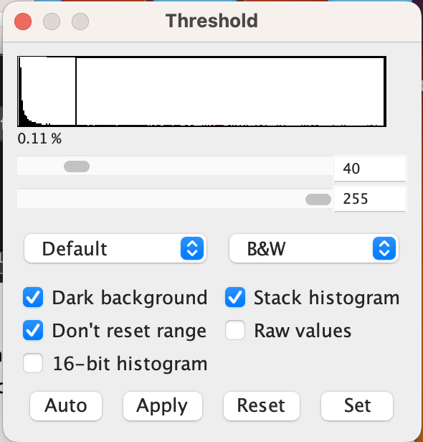
- Make image a mask
  - Go to “Process” tab > “Binary” > “Make Binary” > Check off settings as seen below > Click “OK”
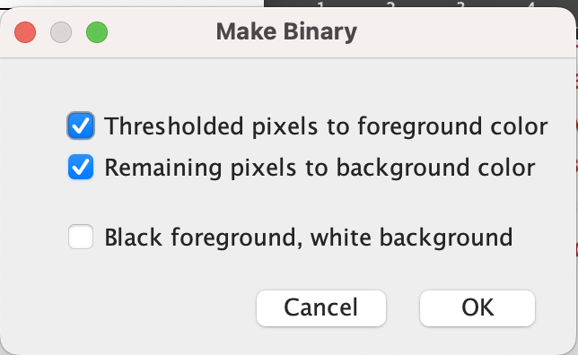
  - Go to “Process” tab > “Binary” > “Convert to Mask”
  - Go to “Image” tab > “Rename” > Rename image to “CD68” to differentiate it
- Repeat this process with the other image.
- Click on the Iba1 (green) image
- Make 8-bit image: Go to “Image” tab > “Type” > “8-bit”
- Adjust threshold: Go to “Image” tab > “Adjust” > “Threshold”
  - Click on “Set” in the popup window and then set the threshold at a consistent value of: Lower 22:, Upper: 255
- Make image a mask
  - Go to “Process” tab > “Binary” > “Make Binary” > Check off settings as seen below > Click “OK”
  - Go to “Process” tab > “Binary” > “Convert to Mask”
  - Go to “Image” tab > “Rename” > Rename image to “Iba1” to differentiate it
- Combine Masks: Go to “Process” tab > “Image Calculator”
  - Set …
    - “Image1” as your “CD68” mask
    - “Operation” as “AND”,
    - “Image2” as your “Iba1” mask
  - Check off “Create new window”
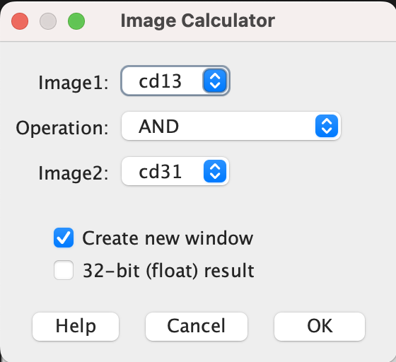
  - Go to “Image” tab > “Rename” > Rename image to “CD68 Iba1” to differentiate it
- Find the % area for the “CD68”, “Iba1”, and “CD68 Iba1” masks
  - Click on the “CD68” mask > go to “Analyze” tab > “Measure” . See note for images with selections
    - NOTE: For images with selections, drag and drop the selection into ImageJ and it will appear on the image. Do this before measuring.
  - Copy/paste this data to Excel immediately, as the results are not labeled with image names and it is easy to get them confused
  - Repeat step 14a and 14b for “Iba1” and “CD68 Iba1” masks

Finding Optimal Threshold Values
- You must find the optimal lower threshold value for each channel (CD68 and Iba1), then this same threshold value will be used for all images
- Start with CD68 and randomly select 6 images from each treatment group (3 from each area hippocampus or cortex)
- Click on one of the CD68 (red) images
- Make 8-bit image: Go to “Image” tab > “Type” > “8-bit”
- Adjust threshold: Go to “Image” tab > “Adjust” > “Threshold”
- Move the slider for the lower threshold value until you eliminate the background noise (graininess) and see only the signals. Record this value
- Repeat for all CD68 images to get the optimal threshold values
- Average all the CD68 lower threshold values. This average value will be used for analysis of ALL CD68 images
- Repeat steps 2-8 for Iba1 images to find the average lower threshold value

